Online Fundraising Instructions for Coordinators

Take your fundraising online!
With the events.stjude.org fundraising website, you can easily double your event’s fundraising totals with minimal effort. In addition to managing your event online, your participants can register and create their own personal fundraising pages.

Boost your fundraising totals online:
- Personalize your event’s page, including photos and messaging specific to your event.
- Use Coaching Email Express to:
  - Import email contacts
  - Customize and send emails to encourage, thank, engage and solicit participants
- Set your fundraising goal and track the fundraising progress of both your event and participants.

Getting Started is Quick and Easy!

Step 1 – Log in to your event management center

Visit events.stjude.org and log in.
Follow the instructions in the email you received after being assigned as an event manager for events.stjude.org.

Note: If you cannot locate the email, please visit events.stjude.org and click on the “Log in” button. If you’ve lost your username or password, please select “Trouble signing in?” to request that information.

Step 2 – Customize Your Event Page

Customize your event page.
Once you’ve logged in to your Event Management Center, select “Edit your event page” to customize your event’s page with event details such as Event Name, Schedule, Date & Time and Event page copy.

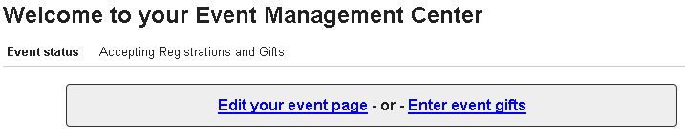

Customize your event page image.

Select “Customize your event image” to upload a new image for your event. You can also use the generic St. Jude image provided.

Have your participants customize their own fundraising page.
Encourage your participants to customize their own personal fundraising page and begin raising money online.

Step 3 – Communicate to CURRENT AND FUTURE participants

Take advantage of the Email tool.
Use the Email tool to manage your email contacts and promote your event. Coaching Emails makes it easy to encourage, thank, engage and solicit participants.

Manage Email Groups
Select “Manage Email Groups” to add your contacts by importing them with a spreadsheet in CSV file format.

Select “Upload New List” and then select “Upload List for Emailing” Give your email group a name and select “Next” You’ll be taken to a page where you can select and upload your CSV file.

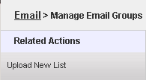

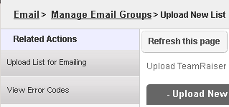

For formatting purposes, please use the “SampleEmailListUpload.csv” file available at upload page to upload your contacts. It’s necessary that your file be in this format in order for it to properly upload.

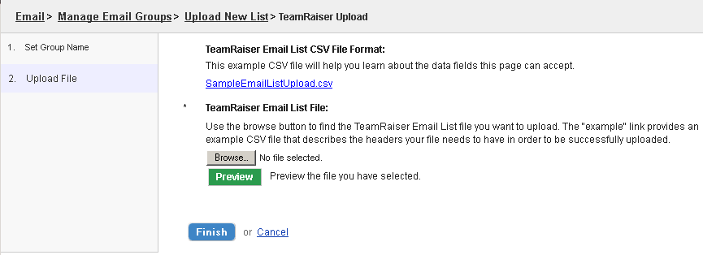

Create and Send Coaching Emails
Customize or choose from the available Coaching Email templates to encourage, thank, engage and solicit participants.

Manage News Feeds
Add content to your event’s news feed. All event participants will be able to view these updates in their Participant Center.

Step 4 – manage your event and view progress

Take advantage of the Event Management tools.
Use these online tools to track fundraising progress, manage participants and enter offline donations.

Track Fundraising Progress
View your event and participants’ fundraising progress at the Event Management Center home page or by running a report. You can share this information with your participants and perhaps recognize the participants raising the most money to encourage friendly competition.

Manage Participants
View participant profiles and fundraising pages. As the coordinator, you have the ability to monitor your participants’ pages, make edits to their profile or close a page if necessary.

Enter Cash or Check Gifts
In addition to accepting online donations, you may also enter off-line gifts to give you a cumulative event total.

Please contact the Coordinator Support Team at 1-800-457-2444 with any questions regarding online fundraising for your event.

